AXIS SETUP FOR AUDIO WITH ONVIF
Axis Camera model Q1615 sample for testing.
Set Audio Settings for G711 etc as shown. For this example the camera was then connected in Valerus.
Gain settings is related to the Mic / Audio source , set according to levels needed.
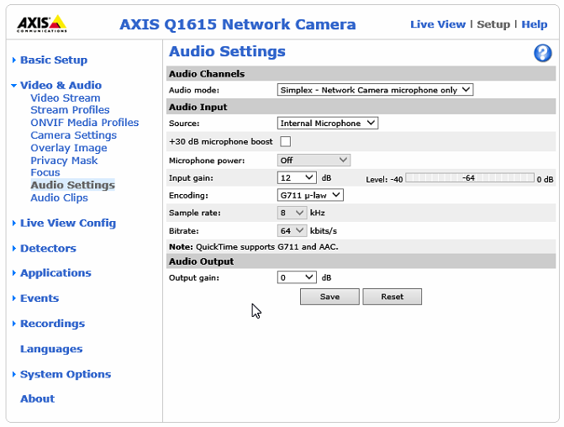

Enable Audio
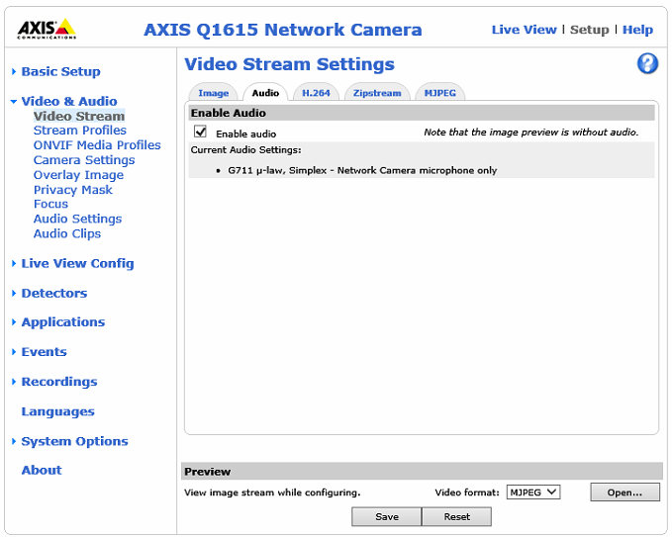

Setup the ONVIF Media Profiles as shown
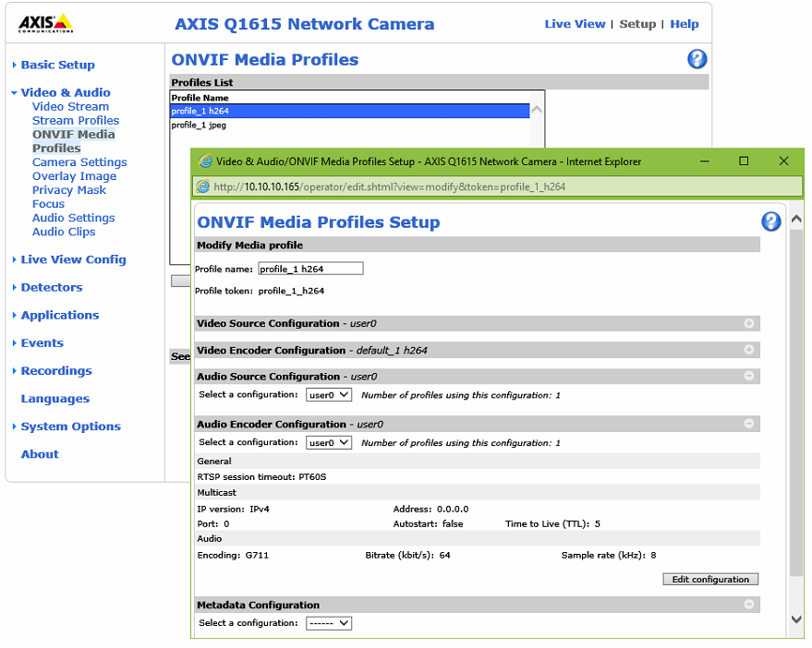

Valerus
