Using the ViconNet Auto Archiver

What is the ViconNet Auto Archiver?
The ViconNet Auto Archiver is a utility bundled with ViconNet versions 8.1.21 and greater. This utility allows one to configure scheduled archiving from the ViconNet audio/video database (AVDB) to external media such as USB HDD, NAS Drive, SAN Storage, or any other storage available to windows. The utility allows one to select a local drive as the destination for storage. Once a storage destination has been selected the utility allows one to select the number of hours to archive as well as an archive end time. The utility works by connecting to the local ViconNet AVDB and archiving a set period of data to the chosen destination. The utility can be scheduled to run automatically via a ViconNet macro and schedule. We will discuss how to configure the utility in the next section.

Initial Configuration
Browse to C:\ViconNet\VnVer\BinRelease and open the AutoArchiver.exe executable. You will see a screen similar to the one in the image below.
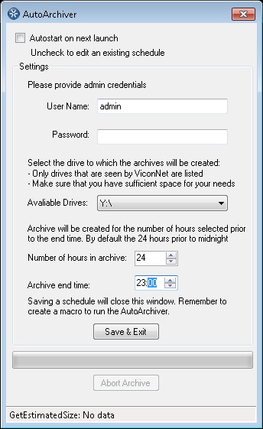
First we must provide the utility with the ViconNet 'admin' user name and password. Without this information the utility will not be able to initialize or run properly.
Next we will need to select a drive from the list of available disk drives. Please note that only drives which are available to ViconNet will be shown on the dropdown menu, by default network drives are not available to ViconNet. If you are planning on using NAS or a mapped network drive then you must first allow archiving to network drives in ViconNet. The option to allow archiving to network drives can be found by going into Setup --> Storage Database --> Remote Archive settings and then checking the 'Allow remote network Drive Archives' option. Save your changes and restart the ViconNet software. Once this is complete we can re-open the Auto Archiver utility and continue with the configuration process.
The next step allows one to select the number of hours to archive. For example, if we wanted to archive the prior days recording we would type in 24 hours. If we wanted to archive once per week then we would type 168 Hours (24x7).
Lastly we will need to select an archive end time. The archive end time tells the utility at which point the archive ends. For example, if the number of hours is set to 24 and the archive end time is set to 23:00 this would mean that the Auto Archiver will start the archive at 23:00 24 hours prior to the current date and time and will end at 23:00 of the current day. Similarly if the end time was set to 00:00 and the number of hours was set to 168 the Auto Archiver would then start the archive at 00:00 168 hours prior to the current date and time and would end at 00:00 of the current day. When creating a schedule in ViconNet for the Auto Archiver one must take into account the 'Archive end time' set in the utility. For example if the end time is set to 23:00 you would want to set the macro schedule to start the task at some point after 23:00 (the end time), for example 23:01.
Once all of the fields have been configured you will want to tick the 'Autostart on next launch' checkbox at the top of the screen and then click on 'Save & Exit'.

Creating a Macro and Schedule for the Auto Archiver Utility
Once the Auto Archiver utility has been configured we must create a macro which will allow us to launch the utility from within ViconNet.
In ViconNet, click Setup --> Select --> Macro Editor --> Add Macro
- Give the macro a name and an accurate description
- From the Commands list select 'Run Application'
- Browse for the AutoArchiver.exe executable under C:\ViconNet\VnVer\BinRelease and select it
- Click on 'Apply' and then 'Save' on the right hand menu
We have now created our macro which will be used to launch the utility.
Once we have created a macro to launch the utility we must add the macro to the macro scheduler, this will allow us to schedule automatic archiving.
In ViconNet, click Setup --> Select --> Schedule for Macros --> Add
- From the macros selection section select the macro we created in the prior step.
- Create a schedule according to your archiving preferences and settings in the Auto Archiver utility. for example for a daily archive, select all start Days, under options select run 1 Cycles , and under 'Active' set the 'From' time to a time which occurs after what is set in the Auto Archiver utility for end time. For example if the end time in the utility is set to 23:00 then set the 'From' time to 23:01 or any other time thereafter.
- Click Save and verify that the Scheduler is enabled (button on top right). If the scheduler is disabled then click on the button in order to enable the scheduler.

Closing notes
The Auto Archiver utility has some error checking and throttling built into itself which should protect it from harming the host system under misconfiguration, error, or unstable operating system conditions.
If the utility is already running a backup operation it will wait for the current archive to complete before it starts a new instance.
Please note that the utility will not perform any deletion of archives on its own. This means that the storage destination must be manually maintained and or cycled. If the storage destination is full the utility will not be able to create any new archives.
The utility stores all video data in the form of a ViconNet archive. This means that ViconNet is needed in order to playback or export any of the archived data.
The utility can also be used to create single instances of archives and can be launched either manually or via the macro in ViconNet.
The utility does not allow for archiving to external media such as CD or DVD.

