System Settings enter IP of the VAX server ( Default would have been the PC Name )
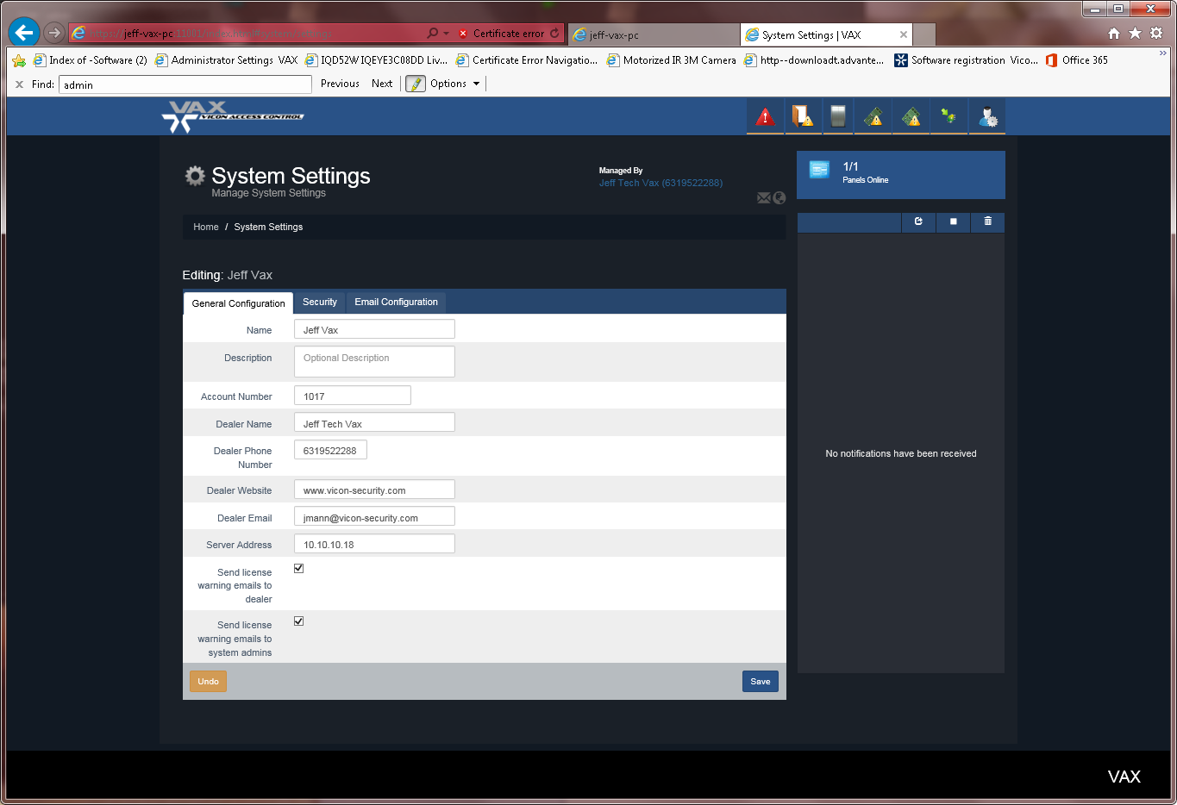
Edit Panel…set connection mode Static ( panel should be set this way) and IP etc of the Panel
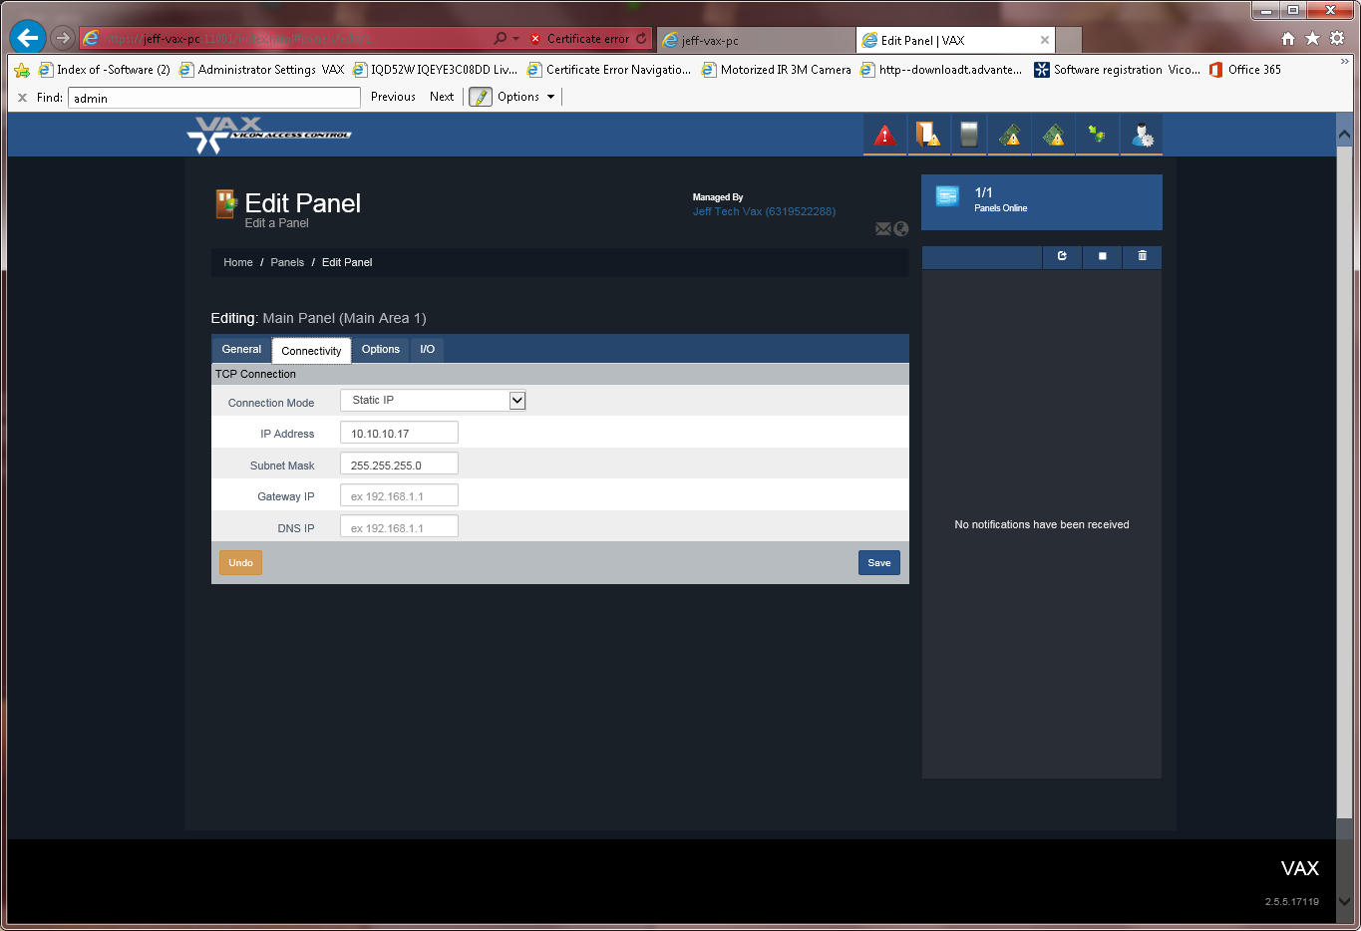
Finally the Panel configuration below should be set as noted.
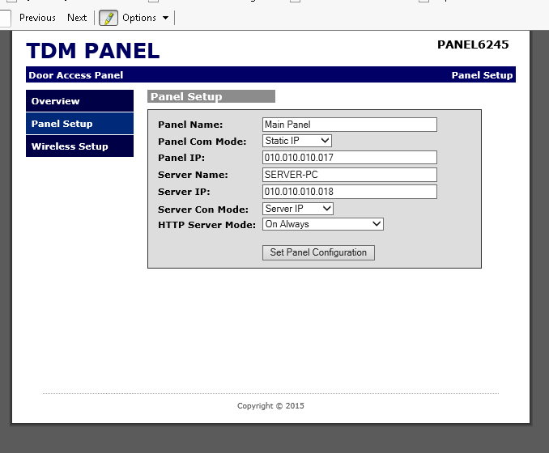
Results
