How to Reset an Unconfigured Bad drive.

A drive may change status to “(Foreign) Unconfigured Bad” if it was removed by accident from the RAID enclosure while the system was running and inserted back in. It may also change the status if a drive from another system was inserted to that slot. If this is the case, make sure to re-insert the correct driver to the correct slot. Check the system’s serial number at the bottom of the tray to confirm which system does the drive belongs to. Otherwise follow the steps below.
Login to the Intel Web Console as “vii” no password. If the alarm is sounding, from the Dashboard, scroll down and click on the “Silence Alarm” link (under the Actions section).
Go to Physical tab.
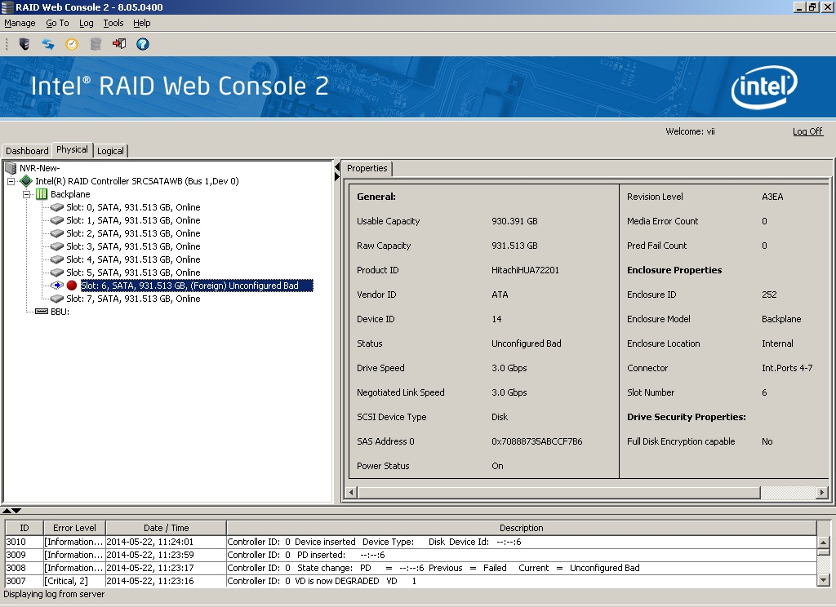

Right click on the Unconfigured Drive then click on Change to Unconfigured Good.
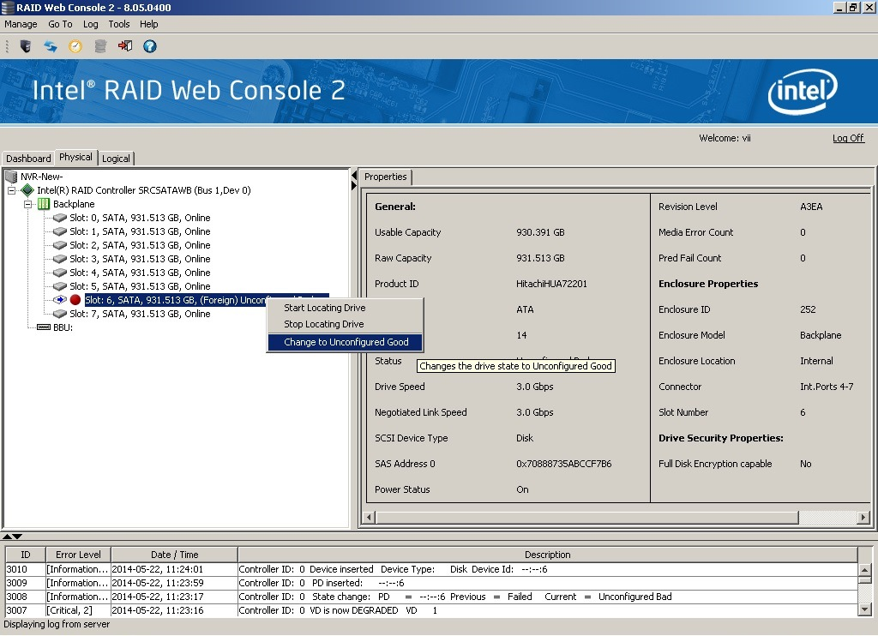
That will change the drive to “(Foreign) Unconfigured Good.”
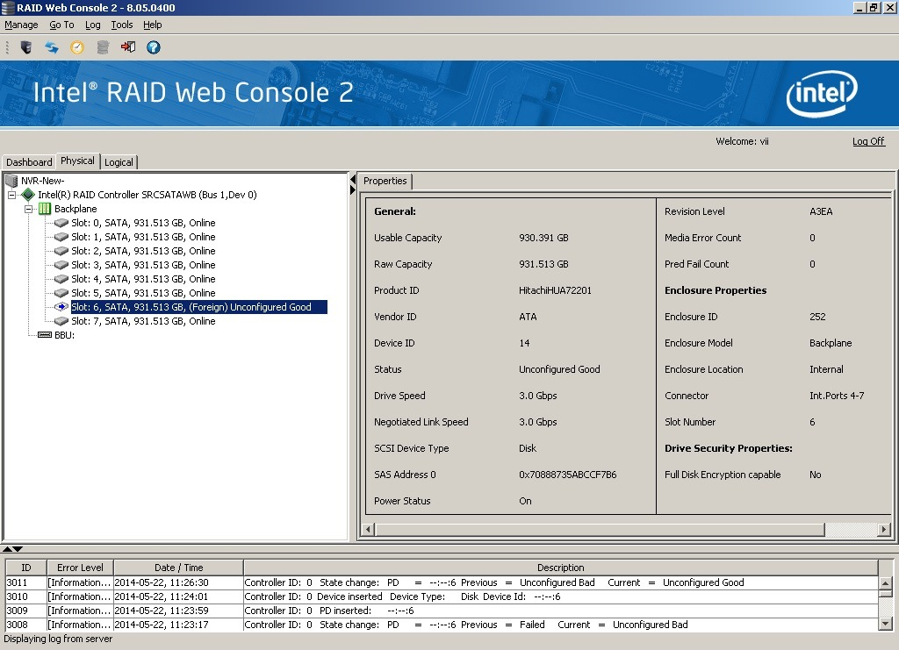

Right click on the RAID Controller then Scan Foreign Configuration.
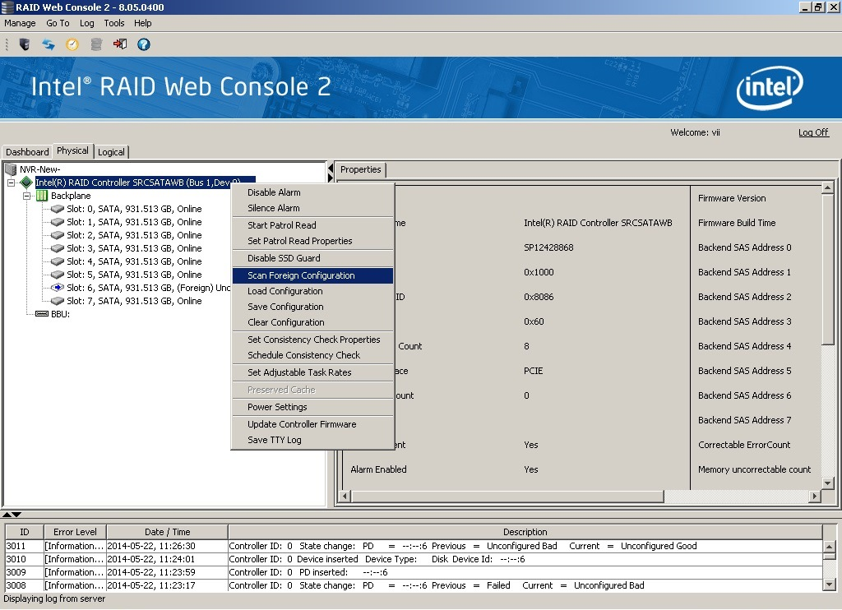
Choose the “Import” option and hi OK.
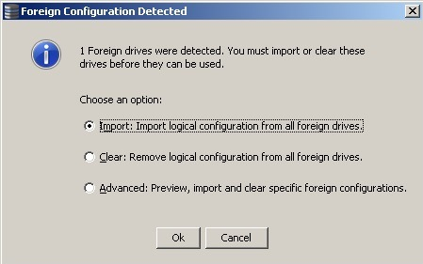
Hit Accept for the Foreign Configuration Wizard and hit Yes to confirm the Import.
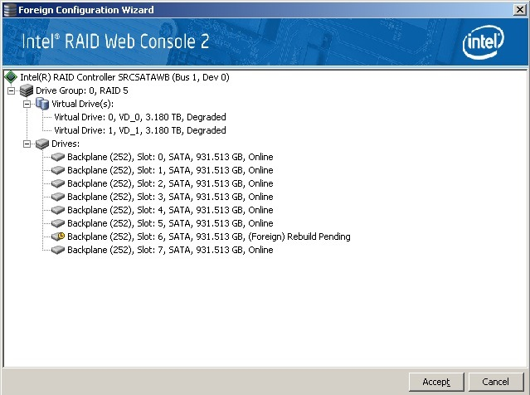
The drive now will start rebuilding.
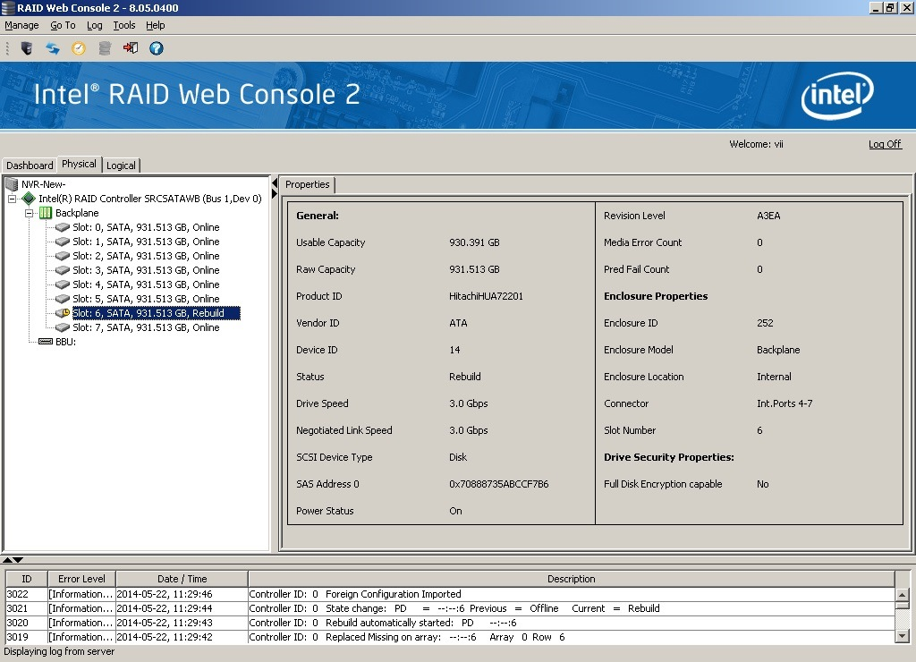
To find out more information regarding the rebuild, go to the Dashboard tab and click on “More details”. The pop up screens gives an estimate how long it will take to rebuild the drive.
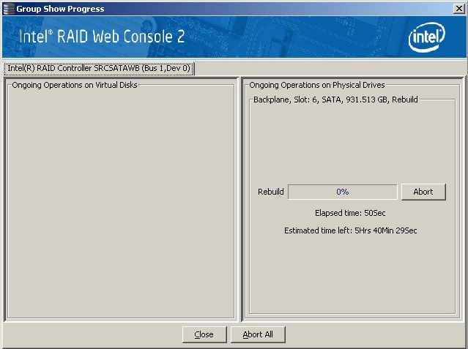
Please note that if the drive is indeed bad, the rebuild process will fail, and at that point, the drive should be replaced. When replacing the drive, the rebuild process should start automatically. If the new drive also fails to rebuild, the RAID Controller backplane might be bad and needs to be replaced.

