The attached “lsigetwin_latest.zip “originally comes from this LINK.
ftp://tsupport:tsupport@ftp0.broadcom.com/outgoing_perm/CaptureScripts/lsigetwin_latest.zip
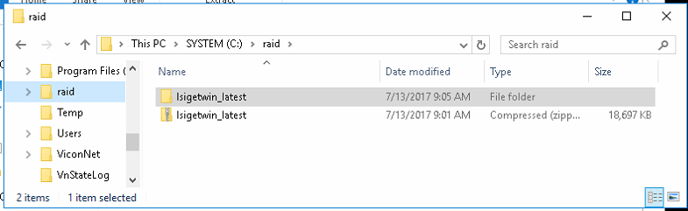
Place this in a folder – suggest C:\Raid

Unzip it. The Unzipped folder will be next to zipped version
go into the unzipped folder you will see;
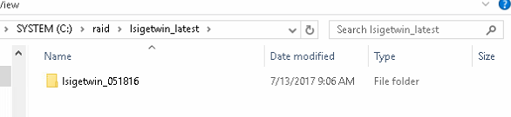
Open the folder and click on this run
Lsigetwin.bat ( extension may not display)
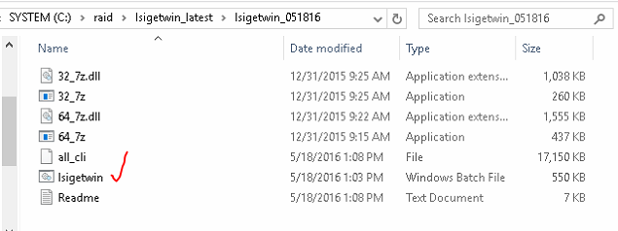

Once you run the .bat file a command prompt window will display let it run
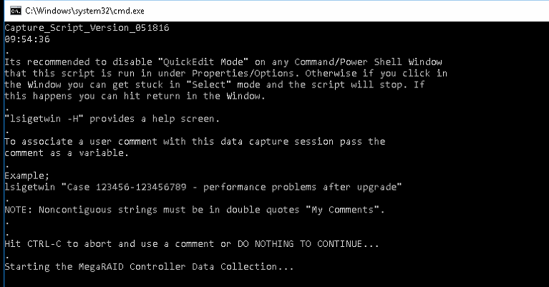

When complete check the folder for file similar to below and send to us by the Sharefile link
lsi.OS_Unknown.NVR-2.071317.90528.7z
